Involving Families
How do we do a better job of involving families to increase student achievement?

“We suggest that your team start with this premise: All families, no matter what their income, race, education, language, or culture, want their children to do well in school – and can make important contributions to their children’s learning. Even if your experience seems to cast doubt on this, thirty years of research bears it out. ...begin in this spirit.” (Henderson, Mapp, Johnson, & Davies, 2007, p. 155)

Build intentional structures, processes, and practices to engage families | 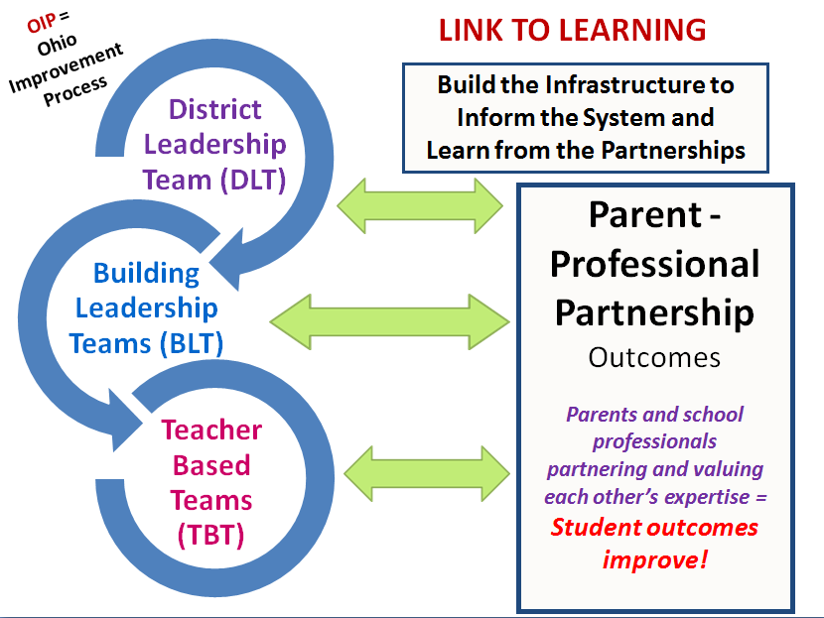
Create a family-school compact for achievement | Five steps for focusing your agreement (compact) on learning:  - Look at your school’s test data with parents.  - Set priorities for improvement and establish a goal for each one.  - Ask parents, students and staff what they should do to meet the goals.  - Focus the agreement on concerns that have come up in discussions. For each area (e.g. homework, communication, rules of behavior) list what each group can do.  - Draw up a first draft, then ask for comments. Revise it based on reactions.  (Henderson, Mapp, Johnson, Davies, 2007, pp. 142-143)

Joyce Epstein's work, through the Center on School, Family, and Community Partnerships, highlights the importance of equity in developing and sustaining school-family-community partnerships that provide more equal opportunities for all families to become involved in ways that support all students' progress and success in school, as well as the critical role that districts play in guiding the development of effective partnerships between their schools and the families and community members they serve.

For information about family and community involvement, see the 2002 publication by Epstein, et al., School, Family, and Community Partnerships: Your Handbook for Action by downloading the pdf: https://www.gpo.gov/fdsys/pkg/ERIC-ED467082/pdf/ERIC-ED467082.pdf and Epstein’s Six Keys to Parent Involvement by download the pdf: file:///C:/Users/Ownr/Downloads/Social%20Identity%20Profile%20sck.pdf

Watch a video demonstrating a Family Friendly School at the Ohio Department of Education’s website.
http://education.ohio.gov/Topics/Other-Resources/Family-and-Community-Engagement/Getting-Parents-Involved/Welcome-To-A-Family-Friendly-Partnership-School

OIP Connections:

DLT and BLT

Assess the level of engagement that your district/buildings have with families using Epstein’s Six Levels of Involvement:
Parenting, Communicating, Volunteering, Learning at Home, Decision-making, Collaborating with Community.
Which areas have the most engagement? Which have the least?

What are the actions that you will take as a district/building to engage with families for the purpose of improved academic success for children?

Resources for involving families:

Dual Capacity- Building Framework for Family -School Partnerships (released by USDOE) Over 50 years of research has indicated that a strong partnership between families and school staff is required not only to achieve educational excellence for all students, but also to improve schools. Dr Karen Mapp, Senior Lecturer on Education, Harvard Graduate School of Education,
USDOE Dual Capacity-Building Framework for Family-School Partnerships
www.scholastic.com/FACE/framework

Sample Best Practices for Parent Involvement webpage on the Ohio Department of Education website shares a number of practices that are based on the State Board of Education’s Parent and Family Involvement Policy, the National PTA’s National Standards for Family-School Partnerships and Joyce L. Epstein’s Framework of Six Types of (Parent) Involvement. http://education.ohio.gov/Topics/Other-Resources/Family-and-Community-Engagement/Getting-Parents-Involved

Reference

Henderson, A. T., Mapp, K., Johnson, V., & Davies, D. (2007). Beyond The bake sale - The essential guide to family school partnership. New York, NY: The New Press.

