Feedback
What is the role of feedback?

Feedback is an important part of the Ohio Improvement Process (OIP). Three kinds of feedback are particularly important:
- feedback from the students to the teacher (to help the teacher understand the impact of his or her instruction);

- feedback to students (from the teacher or peers or from self-evaluation) to help students understand where they are and where they are going; and

- feedback throughout the system.

Feedback from the Students to the Teacher (Formative Evaluation of the System)
Two critical questions to guide all learning are: “Where am I going?" and "Where am I now?" When teachers take these questions seriously, they can begin to evaluate and then improve their practice. A first step is to gather formative evaluation data about their teaching. These data come from students, who provide the minute-to-minute evidence to educators about what is working and what isn't. As educators pay attention to and consider this valuable information, they act on it by making adjustments to their instruction.

As educators begin to think more deeply about the effectiveness of their teaching and help students see where they are in relationship to the learning progressions, their efforts lead to an instructional innovation that has been shown to have a considerable effect on student learning—
feedback.

Hattie (2009) identified formative evaluation of the instructional program as having a substantial impact on student learning (effect size, d = 0.90). In Ohio's model, this type of evaluation occurs naturally as part of the Ohio 5-Step Process at the TBT, BLT, and DLT levels. At the TBT level, teams are interested in formative feedback on the effect of certain instructional practices on student performance. At the BLT level, teams are interested in formative data and information on the degree to which classrooms are implementing agreed on strategies and actions and their resulting effect on performance. And, at the DLT level, the team is look at the effect of implementation on the performance of schools across the district.

Feedback to Students (From the Teacher, Peers, and Self)
Clarity of learning goals and of feedback on their performance helps students understand their own goals and answer the questions, "Where am I going?" and "Where am I now?" When feedback is provided to students from the teacher or peers or from self-evaluation, students come to understand where they are in relationship to their goals.

Feedback between Levels of the System
In Ohio's model, feedback between and among levels of the system (i.e., district, school, classroom) is fundamental to making and sustaining real improvements in instructional practice and student learning. Of primary importance is establishing the appropriate communication and feedback loops needed for effective decision-making over time. Identifying the data and information needed to ensure that the DLT, BLTs, and TBTs are working together, determining how those data and information are shared and used between and among teams, and taking necessary action to address performance problems and replicate successes are critical steps in supporting system learning. The district must define what and how often adult implementation and student performance data will be collected from and provided to teams, facilitating top-down and bottom-up learning (McNulty & Besser, 2011) and specifying what the BLT needs to provide to and receive from TBTs, and what the DLT needs to provide to and receive from BLTs. This feedback loop is illustrated in the graphic below.

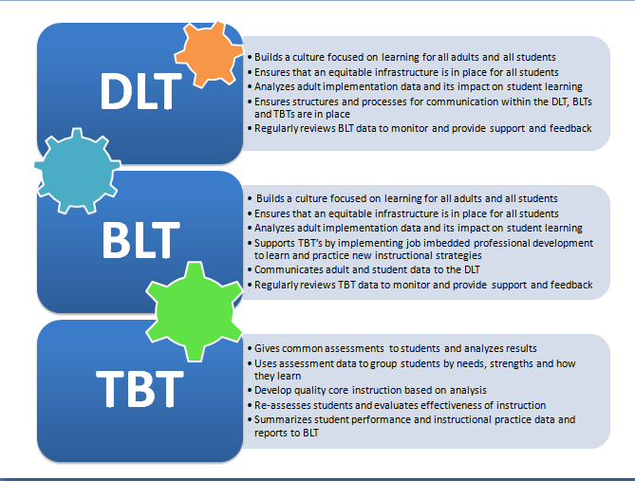

References
Hattie, J. (2009). Visible learning: A synthesis of over 800 meta-analyses relating to achievement. London, UK: Routledge.
McNulty, B.A., & Besser, L. (2011). Leaders make it happen! An administrator's guide to data teams. Englewood CO: Lead + Learn.

