How do we work together in teams to support all students?

Being a Good Colleague and Teacher-based-Team Member

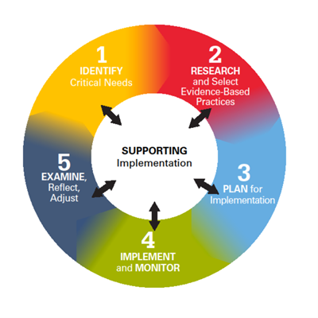

Steps 3 and 4 in Ohio’s Improvement Process for Teacher-based Teams are all about collaboratively designing and implementing high quality instruction. Teams need to decide how the strategies should be implemented, monitored, and checked to see if they are having a positive impact on student learning. The ultimate question, "Did it work?" can only be answered if teachers implement the strategy fully and monitor their degree of implementation.

Watch the Teacher Based Teams in Action video - http://www.ohioleadership.org/view.php?cms_nav_id=30

Activity: Assessing your Building Culture

Uncover the messages the school sends teachers about what it means to teach at your school. At a staff meeting have your staff respond in writing to the prompt,

“For a first-year teacher beginning his/her career at our school,

What messages would he or she pick up about what it means to be a teacher here?
What kinds of professional conversations would he or she recognize as dominating our time?
What would he or she notice about how one develops as a teacher over the course of his or her career if one stays at this school?” (Ritchart, 2015, p. 35)

Share and discuss people’s responses in small groups to identify themes, and then share with larger group.

NOTE: This activity is from Ritchhart (2015).
Many researchers have “advocated for the use of team structures to facilitate shared learning for instructional improvement, noting that no single person has all the required knowledge, skills, and talents to meet the needs of all children. This finding is reflective of the growing body of evidence in support of educators working together to inform each other’s instructional practice, as well as the importance of stable school-based settings and distributed leadership, using explicit protocols, and having coherent and aligned district policies and practices.” (Gallimore, Ermeling, Saunders, & Goldenberg, 2009, p. 7).

References

Gallimore, R.R., Ermeling, B.A., Saunders, W.M., & Goldenberg, C.C. (2009). Moving the learning of teaching closer to practice: Teacher education implications of school-based inquiry teams. Elementary School Journal, 109(5), 537-553.
Ritchhart, (2015) Creating cultures of thinking. The 8 forces we must master to truly transform our schools. San Francisco, CA: Jossey-Bass.

