BASA and the Ohio Leadership Advisory Council are pleased to present...
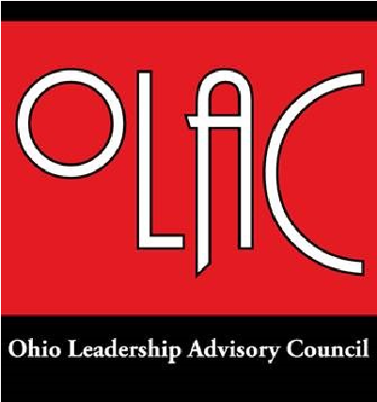

"OLAC Training for External and Internal Facilitators"
Ohio Leadership Advisory Council (OLAC) will be offering a series of regional trainings.
Bring your laptops and ideas! The sessions will be held at the following locations:
Athens-Meigs ESC- October 31 Findlay Inn & Conference Center-November 10
Hamilton County ESC- November 11 Mahoning County ESC-November 18
Richland Government Center- November 28 ESC of Cuyahoga County-November 29
Region 14 Hopewell Center- December 5 Central Ohio ESC- December 8
Become a Certified OLAC Facilitator
By becoming a certified OLAC Facilitator, you will become familiar with and gain an enhanced working knowledge in the following:
- Ohio Improvement Process
- How to use the content of the modules to enhance the effectiveness of district and building leadership teams (DLT, BLT, TBT)
- Ohio Principal Evaluation System (OPES)- Lead Superintendents/Principals through the Principal Standards Crosswalk –this crosswalk aligns relevant OLAC Module materials to each element and standard within the Ohio Principal Standards which represent the basis for the OPES
- Ohio Teacher Evaluation System (OTES)- Lead Principals/Teachers through the Teacher Standards Crosswalk-this crosswalk aligns relevant OLAC Module materials to each element within the Ohio Standards for the Teaching Profession which represents the basis for the OTES OLAC Facilitators will be able to demonstrate how Superintendents, Principals, and Teachers can develop a
Professional Growth Plan that has anytime capability and is free to the participants.
- Credit Options– OLAC Facilitators will become familiar with templates of various workshop offerings using OLAC Modules that can be presented to colleges and universities for consideration for college credit. Facilitators will also become familiar for LPDC credit options available through the OLAC website.
- OLAC Facilitators will also:
- Examine Case Studies of how OLAC Modules are being used
- View webinars and create questions/activities from the content
- Learn to develop a workshop using an OLAC Module

***All participants MUST register to attend as space is limited. Lunch will be provided. Register via email to Julie Turner at turner@basa-ohio.org

"OLAC Training for External and Internal Facilitators"
Ohio Leadership Advisory Council (OLAC) will be offering a series of regional trainings.
Registration Form

*Register via email to Julie Turner at turner@basa-ohio.org

Name : _____________________________________
Title:_______________________________________
Organization:________________________________
Phone:_____________________________________
Email: _____________________________________

Training Location Information – please check the session you wish to attend
Please note: All sessions will begin an 9 AM and end at 2:30 PM. Registration begins at 8:30 AM. Lunch is provided.

[_] October 31, 2016 - State Support Team Region 16 [_] November 10, 2016 - State Support Team Region 6
Athens-Meigs ESC Findlay Inn and Conference Center
21 Birge Drive 200 East Main Street
Chauncey, Ohio 45719 Findlay, Ohio 45840

[_] November 11, 2016 – State Support Team Region 13 [_] November 18, 2016 – State Support Team Region 5
Hamilton County ESC Mahoning County ESC
11083 Hamilton Avenue 7320 North Palmyra Road
Cincinnati, Ohio 45231 Canfield, Ohio 44406
[_] November 28, 2016 – State Support Team Region 7 [_] November 29, 2016 – State Support Team Region 3
Richland Government Center ESC of Cuyahoga County
1495 W. Longview Avenue Room 266 6393 Oak Tree Blvd
Mansfield, Ohio 44906 Independence, Ohio 44131

[_} December 5, 2016- State Support Team Region 14 [_] December 8, 2016 – State Support Team Region 11
Region 14 Hopewell Center Central Ohio ESC
5350 West New Market Road 2080 Citygate Drive
Hillsboro, Ohio 45133 Columbus, Ohio 43219

