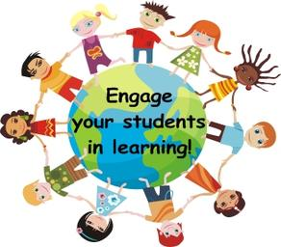
UDL and Content Standards:
Resources for Supporting All Learners

As standards are deconstructed and understood at a deeper level, an educator must consider the needs of ALL students. The principles of Universal Design for Learning (UDL) need to be considered during the planning stages.

There are many effective strategies to support all learners in their progress toward mastery of academic standards. Below is a sample lesson template that is both simple and adaptable to any content area. This Simplified UDL Lesson Plan Template is also available at: http://sstliteracyconnections.wikispaces.com/home.

Literacy Connections Website

An excellent resource for diverse learners is the SST Literacy Connections website (http://sstliteracyconnections.wikispaces.com/home), which provides a rich array of resources focused on improving literacy instruction for learners with deaf-blindness and other low incidence disabilities. The resources—PowerPoint presentations, videos, case profiles, tools, templates, and more—are organized to support regional providers as they work with District Leadership Teams (DLTs), Building Leadership Teams (BLTs), and Teacher Based Teams (TBTs).

The link for District Leadership Teams is: http://sstliteracyconnections.wikispaces.com/DLT

The link for Building Leadership Teams is: http://sstliteracyconnections.wikispaces.com/BLT

The link for Teacher-Based Teams is: http://sstliteracyconnections.wikispaces.com/TBT

Simplified UDL Lesson Plan Template

Standards & Goals

1. __________________________________________________________________________________
1a. __________________________________________________________________________________
2. __________________________________________________________________________________
2a. __________________________________________________________________________________
3. __________________________________________________________________________________
3a. __________________________________________________________________________________

Pre-Assessment:
Expanded Entry Points | Grade Level Target | Extended Skills
Engagement/Anticipatory Set:_____________________________________________________________
______________________________________________________________________________________

Representation/Guided Practice:___________________________________________________________
______________________________________________________________________________________

Expression/Assessments: __________________________________________________________________
______________________________________________________________________________________

Differentiation
Some  (Students who have skills/knowledge) | Most | Few  (students already know material)
Assistive Technology / Interventions – IEP Supports and Services
Low Incidence ----------------------------------------------------------------------------------High Incidence

